FACTORS, MULTIPLES AND PRIMES
Pearson Edexcel - Tuesday 19 May 2020 - Paper 1 (Non-Calculator) Higher Tier
1.
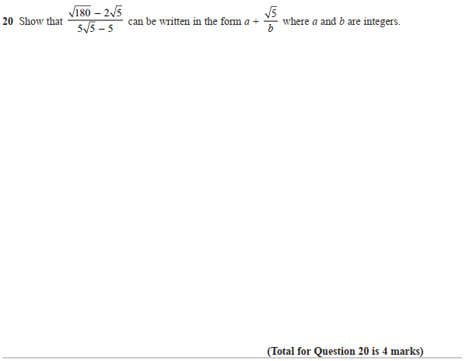

Pearson Edexcel – Thursday 4 June 2020 - Paper 2 (Calculator) Higher Tier
2.
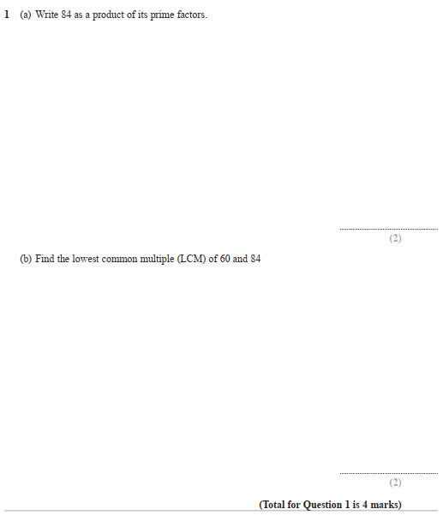

Pearson Edexcel – Monday 8 June 2020 - Paper 3 (Calculator) Higher Tier
3.
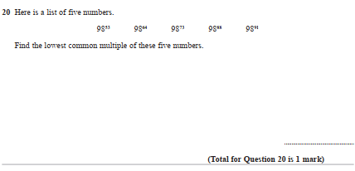

Pearson Edexcel - Tuesday 11 June 2019 - Paper 3 (Calculator) Higher Tier
4.
Pearson Edexcel - Tuesday 6 November 2018 - Paper 1 (Non-Calculator) Higher Tier
5.
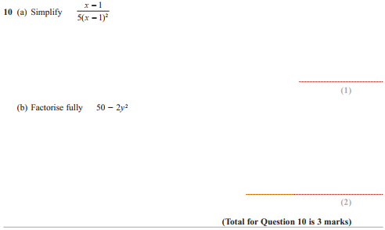
Pearson Edexcel - Thursday 24 May 2018 - Paper 1 (Non-Calculator) Higher Tier
6.
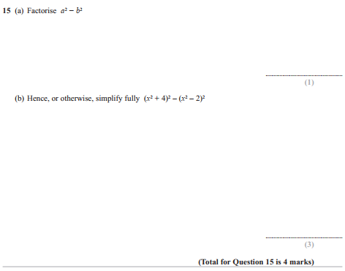

Pearson Edexcel - Thursday 24 May 2018 - Paper 1 (Non-Calculator) Higher Tier
7.
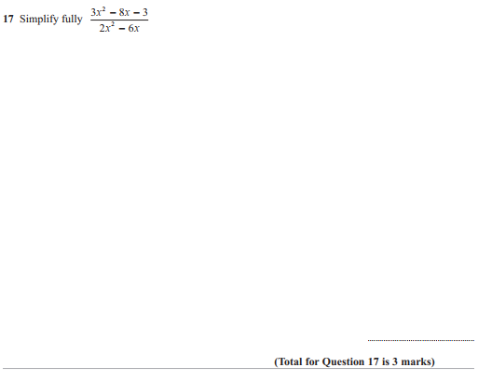
Pearson Edexcel - Thursday 2 November 2017 - Paper 1 (Non-Calculator) Higher Tier
8.
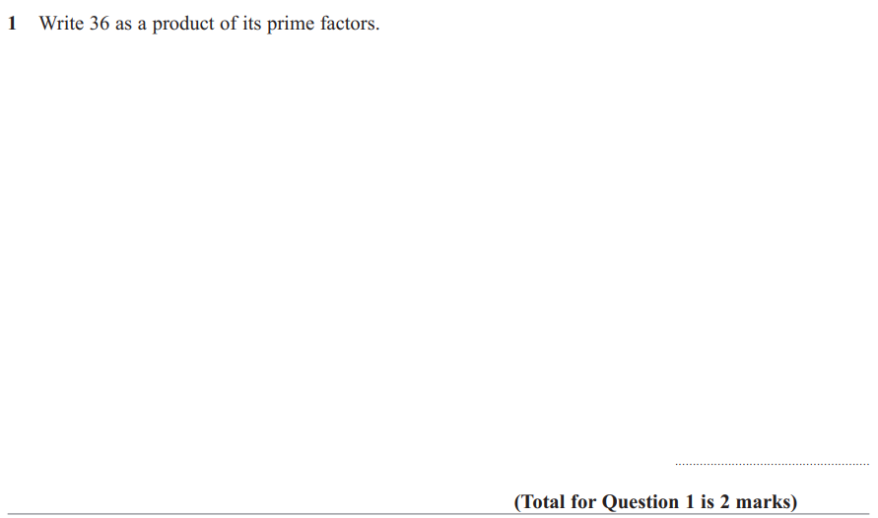
Pearson Edexcel - Wednesday 8 November 2017 - Paper 3 (Calculator) Higher Tier
9.
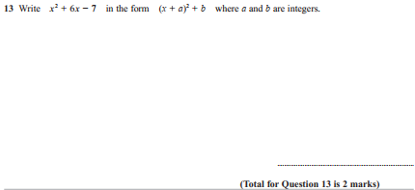
Pearson Edexcel - Thursday 25 May 2017 - Paper 1 (Non-Calculator) Higher Tier
10.
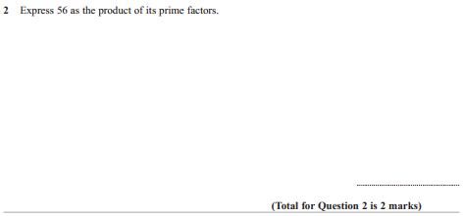

Pearson Edexcel - Thursday 25 May 2017 - Paper 1 (Non-Calculator) Higher Tier
11.
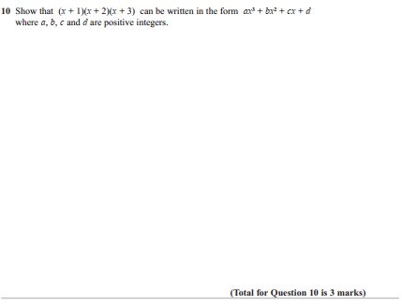
Pearson Edexcel - Specimen Papers Set 2 - Paper 1 (Non-Calculator) Higher Tier
12.
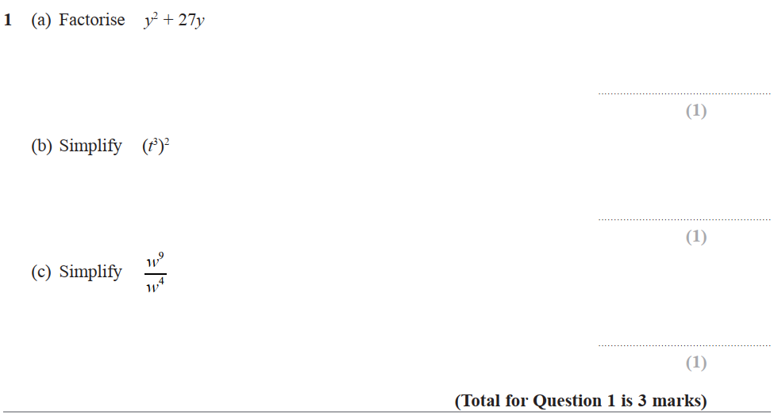

Pearson Edexcel - Sample Paper 3 - (Calculator) Higher Tier
13.
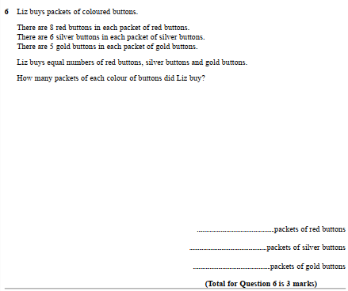

Pearson Edexcel - Thursday 4 June 2015 - Paper 1 (Non-Calculator) Higher Tier
14.
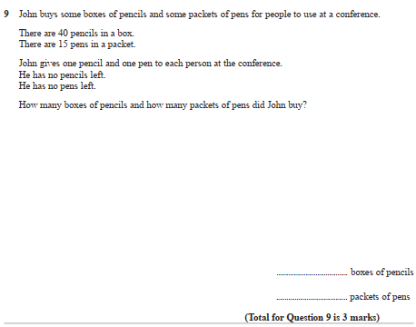

Pearson Edexcel - Friday 13 June 2014 - Paper 2 (Calculator) Higher Tier
15.
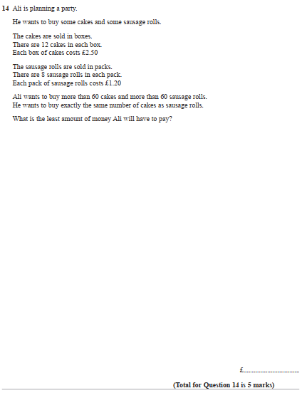

Pearson Edexcel - Tuesday 11 June 2013 - Paper 1 (Non-Calculator) Higher Tier
16.
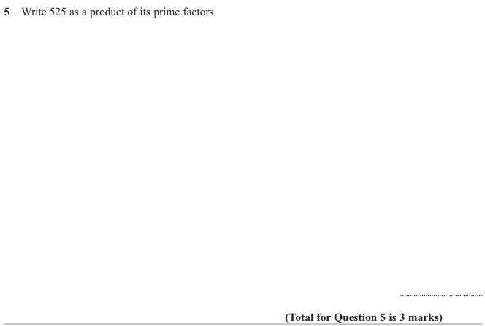
Pearson Edexcel - Tuesday 11 June 2013 - Paper 1 (Non-Calculator) Higher Tier
17.
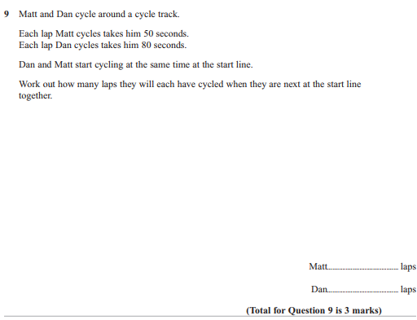
Pearson Edexcel - Friday 10 June 2011 - Paper 4 (Calculator) Higher Tier
18.
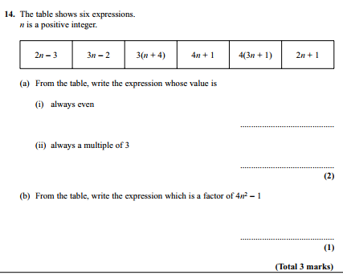

Pearson Edexcel - Monday 7 June 2010 - Paper 3 (Non-Calculator) Higher Tier
19.
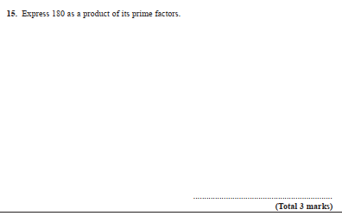
OCR GSCE – Thursday 5 November 2020 – Paper 5 (Non-Calculator) Higher Tier
20.
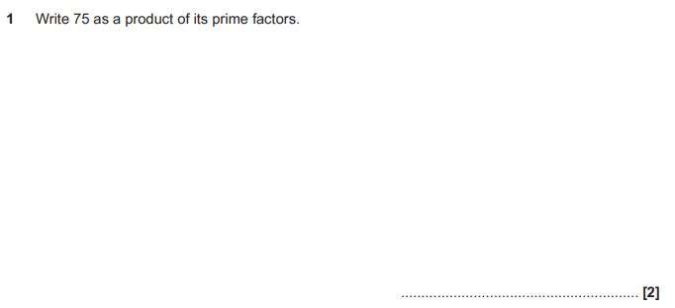
OCR GSCE – Thursday 7 June 2018 – Paper 5 (Non - Calculator) Higher Tier
21.
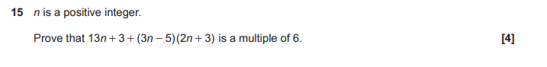

OCR GSCE – Tuesday 6 November 2017 – Paper 5 (Non - Calculator) Higher Tier
22.
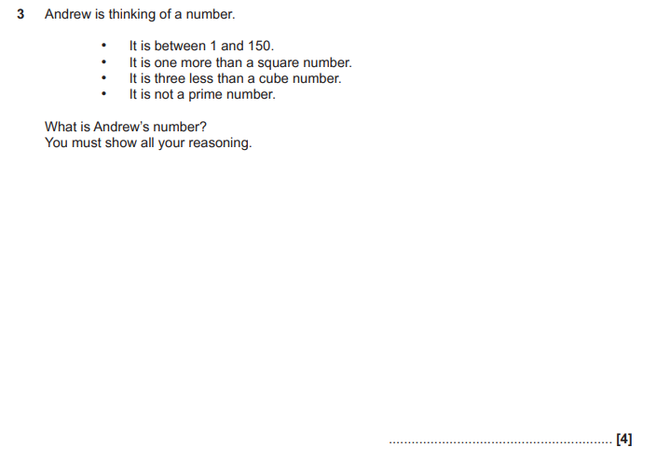

AQA GSCE – Monday 12 November 2018 – Paper 3 (Calculator) Higher Tier
23.
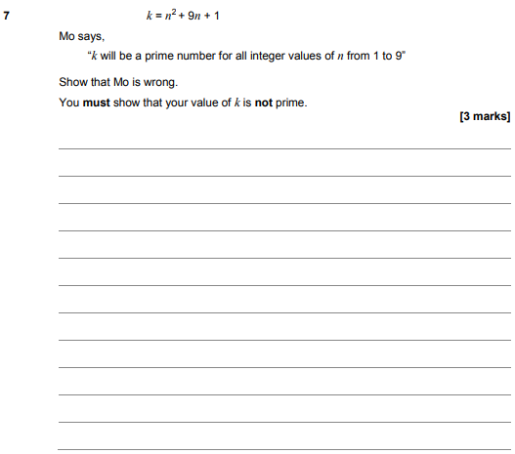

AQA GSCE – Tuesday 12 June 2018 – Paper 3 (Calculator) Higher Tier
24.
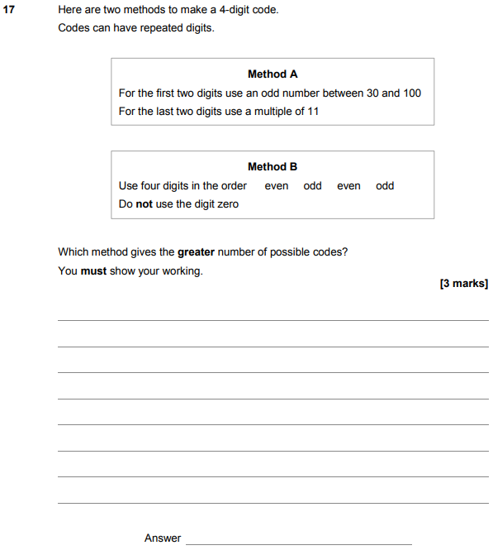

AQA GSCE – Thursday 2 November 2017 – Paper 1 (Non - Calculator) Higher Tier
25.
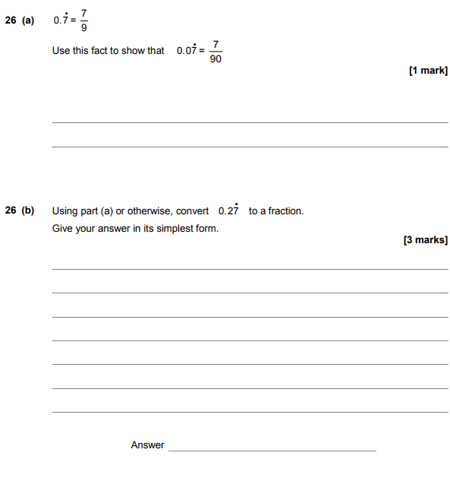
AQA GSCE – Wednesday 8 November 2017 – Paper 3 (Calculator) Higher Tier
26.
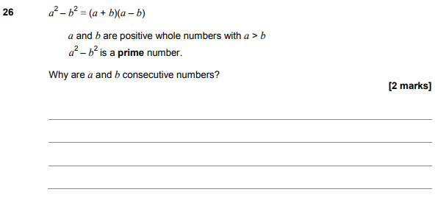
AQA GSCE – Sample Paper 3 (Calculator) Higher Tier
27.

